Holly Olson

cit 230

Brother Blazzard

2-1-18

Web Planning Document

**Site name**

**Weather Watchers**

Author – Holly O.

**Site purpose**

To allow drivers to know what the condition of the weather is on their way to work or school. It gives accurate up dates, so they will be able to check it again before they go home. Or it is for the farmer who wants to know what the weather will be like for their trip to one of the cities.

**Targeted Audience**

My audience is for all of those people who cannot stay in their houses for what ever reason. It could be for work, shopping, or to visit relatives.

**Site map-**

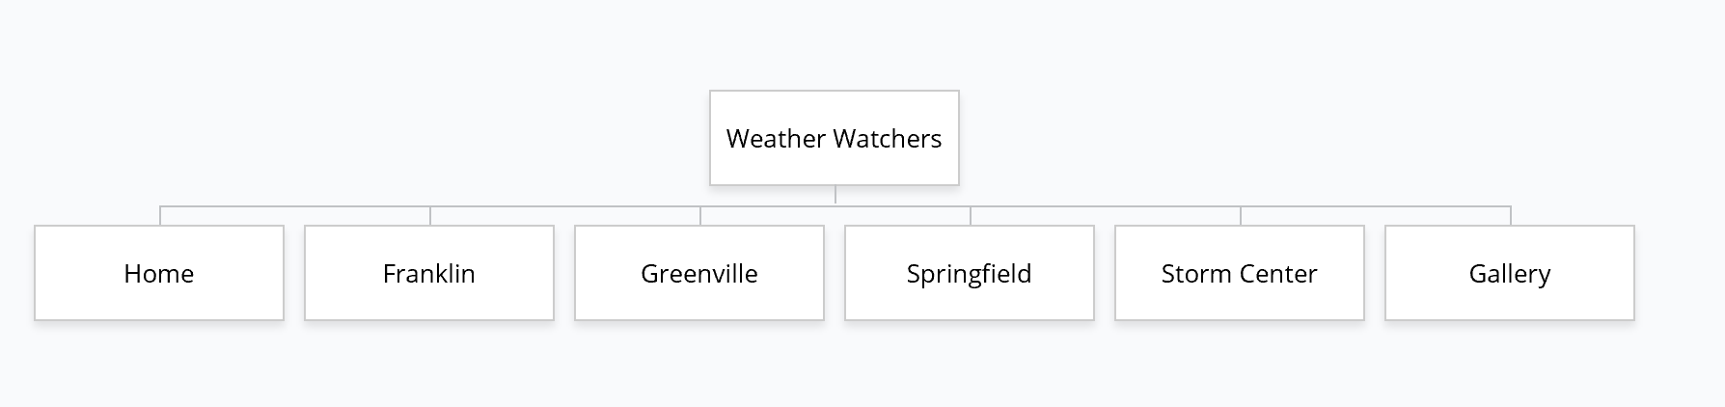

**Color Scheme**

|  |  |
| --- | --- |
| 252,79,93 #1 | 183,130,60 #6 |
| 231,36,47 #2 | 255,229,153 #7 |
| 13,78,96 #3 | 218,199,191 #8 |
| 13,112,85 #4 | 47,84,150 #9 |
| 171,67,60 #5 | 168,208,141 #10 |

For the footer and the header = #2, For menu background = #3, For name of site = #10, Active = #7, Hover = # 1, Visited = # 9, Link =#8, h1-h6 =#4, Text in footer =#6,

**Typography**

1,2,4,5 numbers for temperature box = Arial black

Text in the temperature box = Bradley Hand ITC

Text for h1-h6 and paragraph and other text not categorized = Bodoni MT

Menu Words = Bahnschrift light

**Wireframe links**

Large wireframe- <https://wireframe.cc/4OveVV>

Medium wireframe- <https://wireframe.cc/zplFQ2>

Small wireframe- <https://wireframe.cc/REFuVj>